Curriculum Impact Statement: Maths |  | 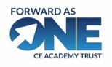
Overview and development (School subject leader):  The consistent daily delivery of Number Sense through lower KS2 has had a continued impact on children’s fluency and recall of multiplicative facts. A high % of children once again achieved 100% in the Year 4 MTS and the mean average has increased:  2023 : 4.3%  2024: 38.5% (with a mean average of 21.4)  2025 : 38.1% (Mean average 22.21)  2026: AWAITING UPDATE  Summer 2: following the completion of Mastering Number, Number Sense will be delivered to year 2 children – with a focus on doubles.  Number Sense sessions have been delivered to a small group of children in UKS2, and others have accessed 1:1 intervention.  Teachers continue to value the impact of quality practice, recall and consolidation of skills – they have a greater understanding of metacognition and the demands on both working and long-term memory in maths.  Mastering Number has been delivered consistently and effectively across EYFS and KS1. Ongoing training and monitoring will continue next year to sustain the progress made.  Moving forward, the subject lead will continue to engage with the TfM programme and implement Mastering Number into year 3.  Subject leadership - CPD, Monitoring and books:  The Subject Leader has attended termly trust meetings, working alongside colleagues to refresh skills and gain deeper understanding and insight into the Mastering Number Programme, but more importantly to appraise how the fundamentals of Mastering Number support TfM. Where possible, staff have also attended training alongside the Maths Lead to enrich their own practice.  For another year, the subject lead has engaged with the NW1 Hub - Teaching for Mastery working group (Phase 2). Maths colleagues have worked collaboratively, visiting different schools to appraise their fidelity to TfM, sharing insights and strengthening practice across a group of schools. This has included learning walks – exploring different contexts and reviewing the mastery journey. The group have continued to explore ways in which to enrich mathematical discourse through effective teacher modelling and have looked more closely at one the big ideas: representation, where teachers highlight the essential features of a concept by systematically changing certain elements while keeping others constant. Rather than mindless repetition, it encourages deep thinking and intelligent practice.  Maths books have been monitored, which has identified some key strengths:  - Work shows clear progression of skills across the term/unit.  - Learning objectives are clearly stated and mainly linked to the work completed.  - Pupils are given regular opportunities to practise key skills – retrieval and fluency tasks  - Evidence of reasoning and problem-solving is included  - Use of models and representations (e.g. number lines, arrays, bar models) is evident  - Challenge is evident through extension or deeper thinking tasks – especially in 5/6  - Strong focus on procedural fluency – quality practise  Across school, there is clear progression and coverage of the National Curriculum objectives; aligned with the White Rose schemes for learning. In some areas of school, particularly in UKS2, Ready to Progress Statements are used to prioritise learning and to ensure that all children access the full breadth of the maths curriculum. Next year, additional support for adaptive teaching will be provided in classes where required.  Following termly assessments, most teachers are proficient in using QLAs to inform planning and drive intervention; identifying target groups and tailored provision. This QLA has also been used to communicate progress and attainment to parents on school reports / meetings.  Actions moving into 26-27:  1. Improve Consistency of Presentation  - Revisit and reinforce expectations for maths presentation (dating, margins, one digit per square, alignment of calculations).  2. Strengthen the Impact of Self-Marking  - Provide clear staff guidance on when self-marking is appropriate and when teacher marking is required to inform immediate next steps, such as same-day intervention, targeted questioning or revisit tasks.  3. Ongoing Monitoring and Support  - KB to conduct regular, focused book scrutinies with a specific emphasis on marking, misconceptions and pupil response.  - Provide CPD or staff guidance on effective marking in maths and subsequent adaptive teaching. | Maths in the EYFS:  There continues to be a strong focus in the EYFS on developing early maths. Children are provided with daily opportunities through Teacher led activities and in provision allowing children to revisit and deepen their knowledge and problem-solving skills. The outdoor area is developing to harness children’s curiosity and explore mathematical concepts through play – including the exploration of shape and measures. The NCETM Mastering Number programme continues to be delivered with fidelity to develop proficiency and automaticity in number facts and recall.
Data overview
Percentage of children at Age Related Expectations AWAITING UPDATE
End of Key Stage 1 | End of Key Stage 2 | Whole school

Assessment information taken from unit overviews shows:
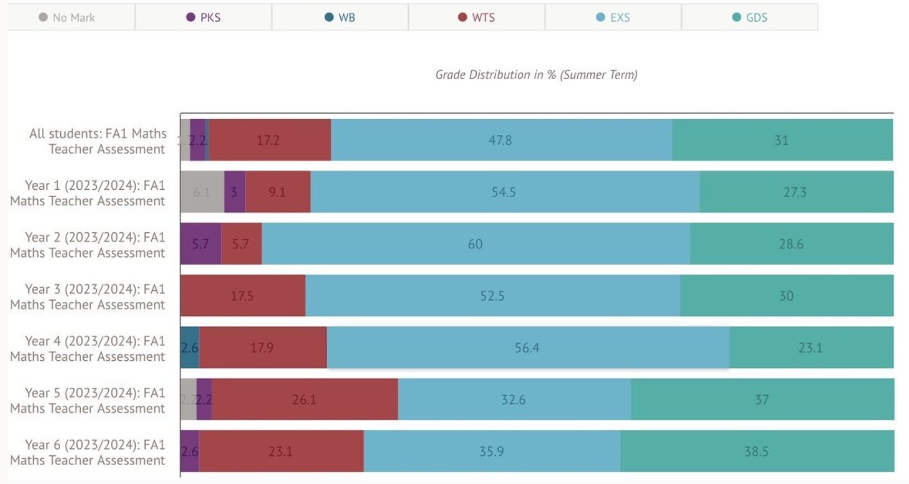
Awaiting updated data 25/26
DETAIL NEXT STEPS HERE
xxxxx
Pupil voice
Pupil voice across the school was overwhelmingly positive, with children demonstrating a strong sense of pride in their mathematical learning. In KS1, pupils spoke confidently about using working walls to support their understanding and valued the opportunity to practise skills through different learning stations. They were eager to share their work with adults and took pride in their achievements.
In LKS2, pupils recognised the increased challenge of mathematics in Year 3 and expressed a desire for greater access to manipulatives to support their understanding, as they had experienced in KS1. UKS2 pupils appreciated the tailored nature of lessons and the autonomy to select appropriate levels of challenge or consolidate previously taught skills. They particularly enjoyed collaborative tasks that enabled them to discuss strategies and solve problems together.
Across Key Stage 2, pupils identified mathematical reasoning as an area they found more challenging, particularly when explaining their thinking using precise mathematical vocabulary. However, children who accessed the Number Sense intervention reported increased fluency and confidence, commenting that it had helped them tackle more challenging mathematics successfully.
Overall, pupils spoke positively about mathematics, recognised their own progress and could articulate how mathematical skills are important in a range of careers and real-life contexts.

