
Curriculum Overview for Forest School for KS1
Overarching Themes which will be taught and explored throughout the year
Knot Skills and Tool Use |  | Seasons |  |  | Habitats |  |  | Trees/ Living Things |  |  |  |  | Building and Fire
Introduce the children to knot skills. Look at the structure of the rope e.g. the working end, the dead end and the working part.  Learn and master basic knots: overhand/ stopper knot, figure of eight, clove hitch. |  | (Y1 objectives)  Pupils should be taught to:  - observe changes across the four seasons  - observe and describe weather associated with the seasons and how day length varies |  |  | Observe the animal habitats in the school grounds and begin to learn their names e.g. a rabbit warren, a badger sett, a squirrel’s drey, a fox’s den.  Look at the varying habitats of minibeasts such as log piles for beetles, webs for spiders, a pond for water snails, meadow/long grass for flies, lacewings, stink bugs etc. |  |  | Plants  (Y2 objectives)  Pupils should be taught to:  - observe and describe how seeds and bulbs grow into mature plants  - find out and describe how plants need water, light and a suitable temperature to grow and stay healthy  Animals, including humans  (Y1 objectives)  Pupils should be taught to:  - identify and name a variety of common animals that are birds, fish, amphibians, reptiles, mammals and invertebrates  - identify and name a variety of common animals that are carnivores, herbivores and omnivores  - describe and compare the structure of a variety of common animals (birds, fish, amphibians, reptiles, mammals and invertebrates, and including pets) and describe how they are suited to their environment |  |  |  | Become familiar with the different properties of building materials found within the school grounds and the forest school site (e.g. willow for bending shapes). Use knowledge and understanding of materials and tools to construct and secure with knot tying skills.  Learn about the fire triangle. Learn how to build a small non-traceable fire. Collect the relevant materials (tinder: dried leaves and bark from the Silver Birch Tree) and correctly sized sticks etc.(kindling). Adhere to fire safety rules and procedures.
Overarching Forest School Skills
Cooperation  - Sharing, cooperative play, awareness of consequences of actions.  - To listen to and follow rules and instructions and to adhere to safety precautions. |  |  | Self-Esteem and Self-confidence  - Increased self-confidence and self-belief from freedom, time and space, to learn, grow and demonstrate independence. |  |  | Motivation  - A keenness to participate in exploratory learning and play activities.  - An ability to focus on specific tasks for extended periods of time. |  |  |  |  | Decision- Making  - Given the opportunity for real-life problem-solving.  - Encourage them to maintain something which they have planned.  - Enable them to have an element of control over their own learning environment.
Characteristics of Effective Learning  Planning and resourcing provision, will reflect the different ways that children learn:  Playing and Exploring - children investigate and experience things, and ‘have a go’;  Active learning - children concentrate and keep on trying if they encounter difficulties, and enjoy achievements; and  Creating and thinking critically - children have and develop their own ideas, make links between ideas, and develop strategies for doing things. |  |  |  |  | Playing and Exploring  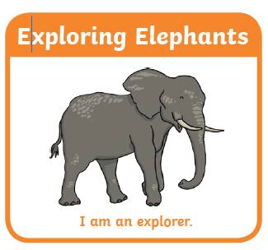 |  |  |  | Active Learning  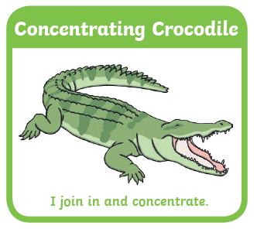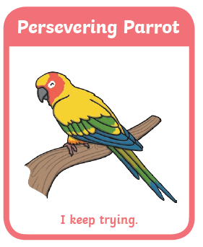 |  |  |  | Creative and Critical Thinking  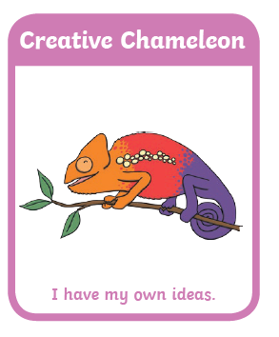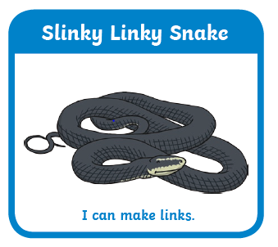
Long Term Plan
Cycle One | Autumn 1 |  |  | Autumn 2 | Spring 1 |  | Spring 2 |  |  | Summer 1 |  |  |  | Summer 2
Skills | Stick safety  Measuring Sticks  Observation skills |  |  | Knots- overhand/ stopper  Use of tools (mallet) | Collecting and gathering materials for building a fire  Knots-figure of eight |  | Knots-Clove hitch  Use of tools (mallet) |  |  | Knots and square lashing  Den building/ shelters |  |  |  | Collecting and gathering materials for building a fire  (Cooking/toasting marsh mallows)
Cycle One | Trees  Autumn Leaves  Journey Stick |  |  | Seasons  Day and Night  Hibernation | Fire  (The Great Fire of London)  Warmth and nesting |  | Life Cycles |  |  | Animals and Plants |  |  |  | Primitive / Nature Collage  (Earth Art)
Cycle Two | Trees, wood, fire  (Guy Fawkes, The Gun Powder Plot) |  |  | Seasons  (Andy Goldsworthy  Fire work art) | Fire  (Fairies, woodland spirits and myths)  RSPB Birdwatch |  | Plants and Animals |  |  | Seasons/ Weather |  |  |  | Trees

