Curriculum Impact Statement: PSHE/RSE | 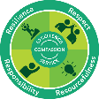  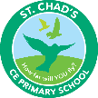  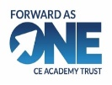
Overview and development:  - The key themes have been identified as relationships, wider world (digital literacy) and health and wellbeing.  - Within these themes learning objectives have been added in a progressive way (designed for opportunity for retrieval and consolidation).  - Within these learning objectives context specific objectives (e.g. related to canals and digital literacy) have been added.  - Substantive knowledge, disciplinary knowledge and skills have also been mapped.  - PSHE vocabulary has been mapped across school so that it is progressive.  Current focus  - Reinforce understanding of school values and behaviour expectations  - To update the new PSHE curriculum to reflect the new DfE guidance  - Increase parental engagement with workshops  - To enhance career opportunities for pupils  Actions  - Ensure school values, behaviours and rules are consistently understood and referenced by both staff and pupils through PSHE lessons, collective worship and daily practice. Pupils and adults use a shared language around behaviour and values, further strengthening the respectful and positive school culture  - To explore PSHE schemes that are progressive and build upon prior knowledge, revisiting themes annually to deepen understanding and skills as pupils move through school.  - Explore alternative formats and timings for workshops and gather parent feedback to increase  Participation/ share content from new guidance/ chosen scheme.  - Summer term career/diversity-based parent assemblies/ Working with TransPennine Route Update (TRU) to improve awareness of careers and biodiversity particularly within our own locality/ Working closely with the Dovestone reservoir team (learning about the ecosystem within our locality, fire/ water safety) | PHSE in the EYFS:  In the Early Years Foundation Stage, PSHE is referred to as personal, social and emotional development consisting of the three key areas - Managing self; Self-regulation and Building relationships. PSED is considered as a prime area within the early learning outcomes. Planning consists of an element of child led interest to reflect both the needs of the children and school as well as the Think Equal programme. Think Equal is a holistic Early Years Programme based on a commitment to social equality, gender, racial and religious equality, social and emotional health and well-being and global citizenship, based in social-emotional learning. The programme views children as individual parts of a collective, global fabric and aims to support them as they begin a lifelong learning journey unburdened by the restraints of discriminatory mindsets. It endows them with knowledge and experiential understanding of values and life skills or competencies such as empathy, inclusion, self-confidence, emotional literacy, self-regulation, peaceful conflict resolution, and so forth. It encourages and empowers them in assuming responsibilities as global citizens and becoming ‘upstanders’ and transformers of society through the use of critical, inclusive and creative thinking. Teachers record children’s ideas in the class book.  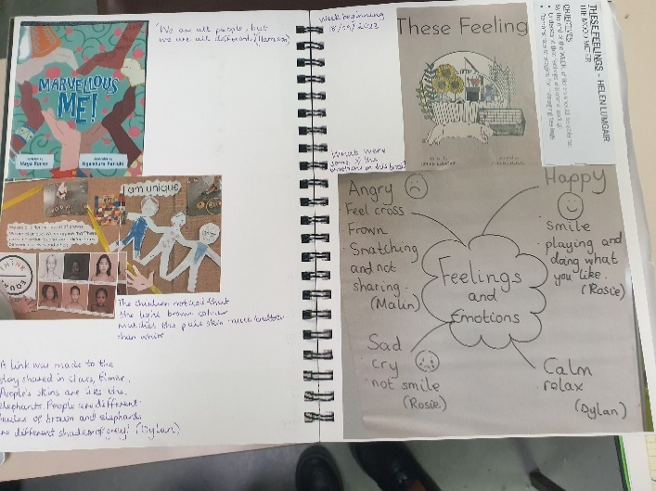  A sample from EYFS class book. The teachers aim to capture evidence through range of stimuli. Children listen with enjoyment to a wide variety of stories. A thinking floor mat is used to organise, clarify thinking, feeling etc. Children are encouraged to use their imaginations through art, role-play, music and much more to express their thoughts and feelings.
Data overview Percentage of children at Age Related Expectations
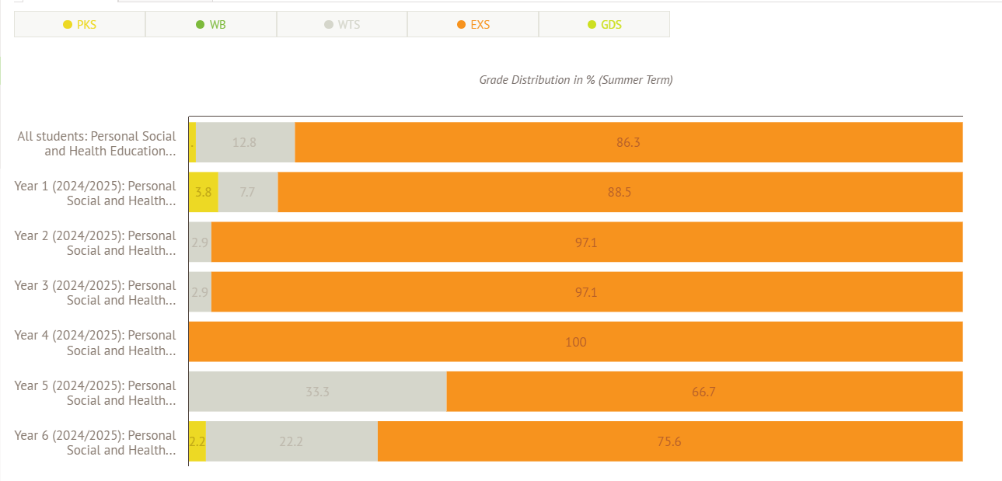
The data suggest that most children over 86.3% (196 chn) of children work at or above for PSHE.RSE.
Out of the 12.8% (29chn) children who are working below or towards their expected level, majority of children appear to be with SEND or those with exceptional circumstances. Those with SEND have their personalised personal, social and emotional development targets have been mapped on their EHCP/ PCRs and those going through exceptional circumstances are gaining additional support through internal/ external interventions.
Next steps: monitor
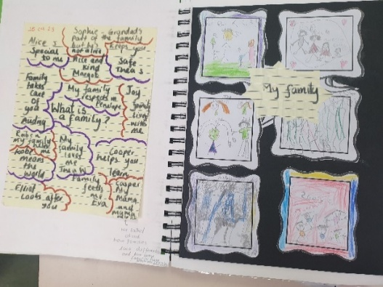
Assessment information taken from unit overviews:
Teachers record pupils learning (pupil voice) in a range of creative ways (observations, role-play, pictures recordings with QR codes, mind maps, photographs and videos) in PHSE class books. Teachers keep a record of children’s progress in a termly marking document and use this to inform their summative assessments.
Pupil voice
“PSHE has helped me to look after my mental well-being. It has taught me how looking after physical well-being can help us stay calm.” (OB)
